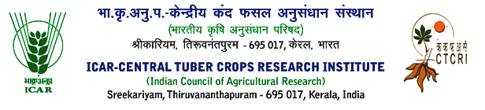

|  |
| --- |
| **Recruitment for Young Professional-I**  Director, ICAR-Central Tuber Crops Research Institute is pleased to appoint Mr. Nikhil K. S, Kumbrottil H.O, Pedayanthal, Chokkad P.O, Malapuuram, purely to the temporary position of Young Professional I on Contract basis for IT related works in lab and at field at ICAR-CTCRI, Thiruvananthapuram (Reference : Advertise F.No.19-1/2024-Admn.Dated: 16.08.2024).  **Senior Administrative Officer** |